Unit 6 Day 6

I need some fruit.

Get some fruit at the grocery store, please!

Can you say the word **jam**?

What is the first sound you hear in the word **jam**? /j/

What is the first letter in the word **jam**?

What sound do we hear in the middle of the word **jam**? /a/

What is middle letter of the word **jam**?

What is the ending sound in the word **jam**? /m/

What letter is at the end of the word **jam**?

Which of these words have the same beginning sound as **jam**?

House Juice Soup Jet

Around the community, there are many different places to get different things. Let’s list what we want to buy and figure out which place we can go to get these items.

Things I want to get:

Cereal Letter from grandma Books

Soup Bread Toys

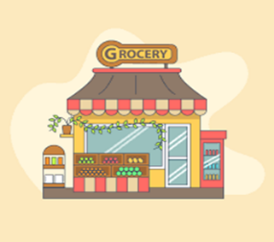

Where can I get cereal?

I can get cereal at the grocery store.

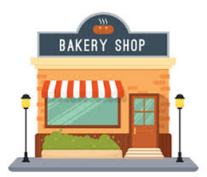

Where can I get bread?

I can get bread at the bakery.

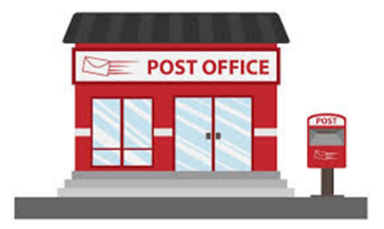

Where can I get a letter from grandma?

I can get my letter from the post office.

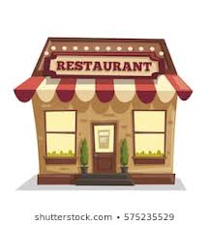

Where can I get soup?

I can get soup at a restaurant.



Where can I get books?

I can get books at the library.

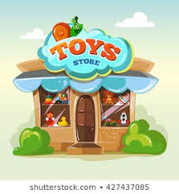Where can I get toys?

I can get toys at the toy store.

Activities! You are welcome to do all of these activities but please do at least three of them.

1. Have your child write 4 sentences like the ones above. Have your child chose an item they wish to buy and where they can get the item. Have their sentences look like this:

Where can I get vegetables? I can get vegetables at the grocery store.

1. Have your child draw a picture of their favorite place to go in their community.
2. Have your child write the name of their favorite store 5 times each. They might need a visual. So, write what their favorite store out and then let them copy what you wrote.
3. Have your child practice these simple sight words 5 times each (thank, hear, went, body, off). This means to say the word, have the child say the word, and write the word.